Zones of the Earth

Original impressionistic (hand-drawn) charts: purchase here
Purchase the MFE charts here.

Note: This chart focuses only on the TEMPERATURE of the different zones, and does NOT take into account all the other factors that contribute to CLIMATE (such as: precipitation, currents, altitude, etc.)

MATERIALS:
- Chart 18a

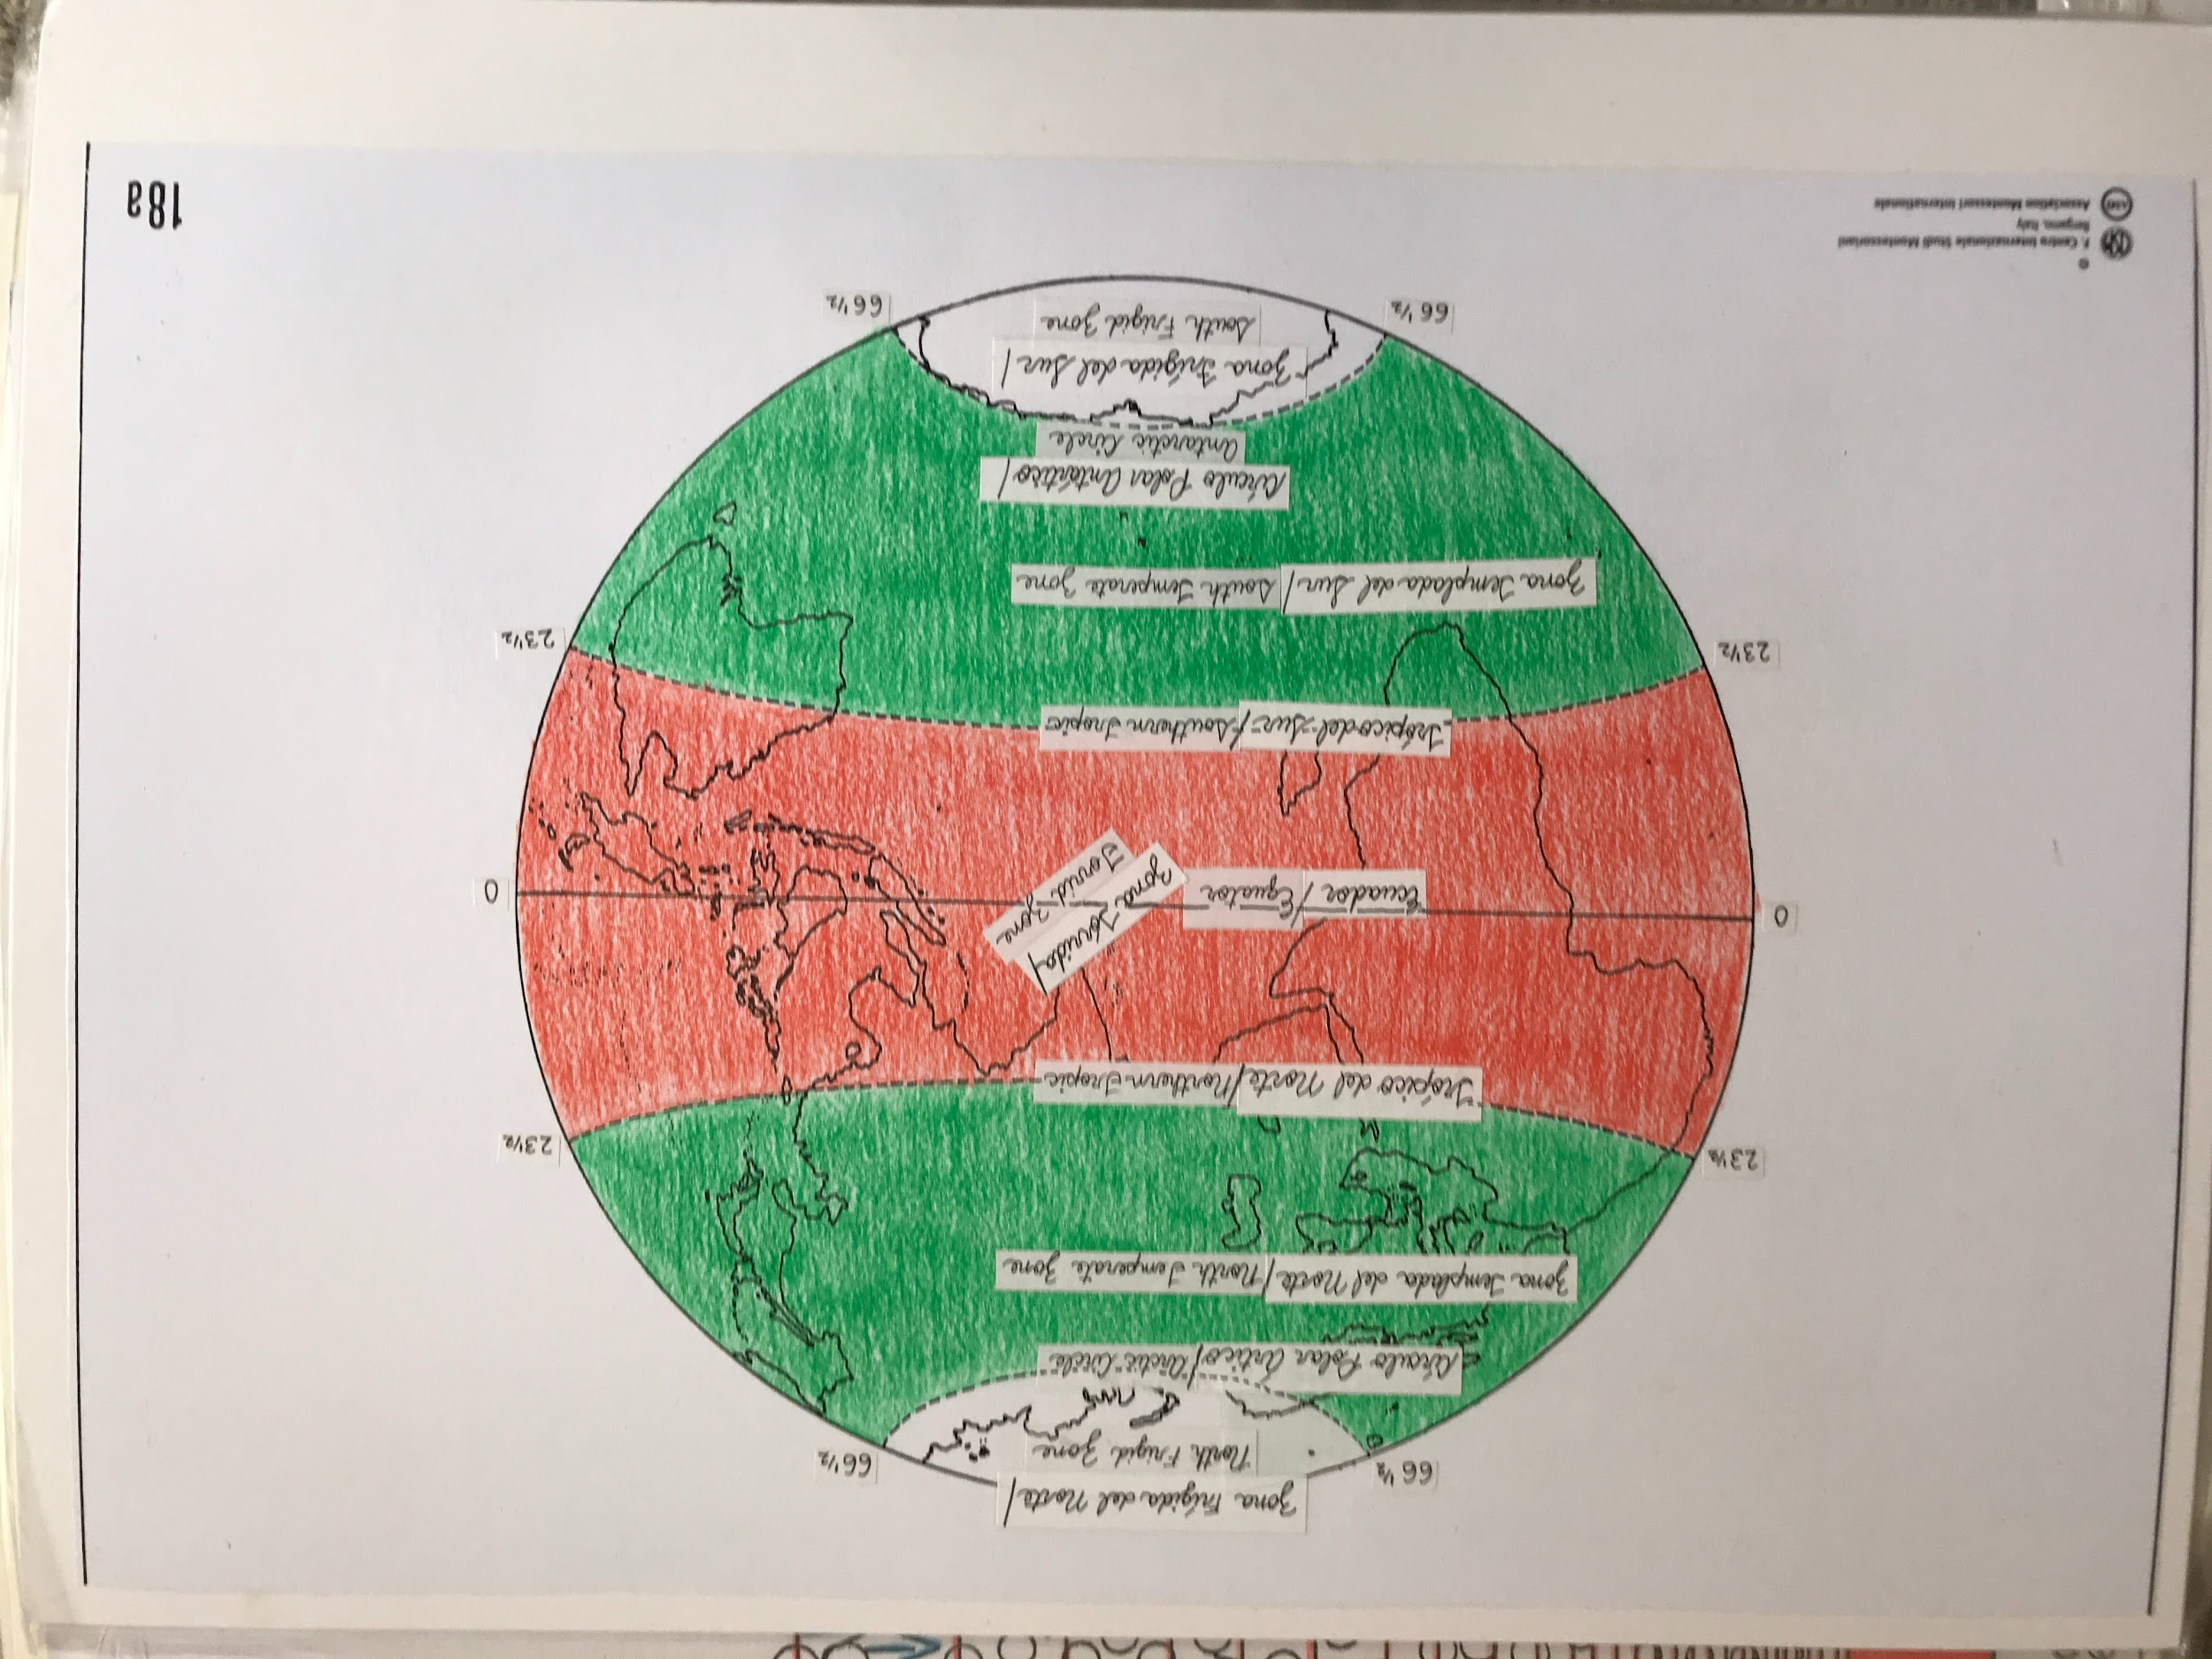

To make your own chart, print out a globe with the Tropics, Equator, and Polar regions, and color/label as follows:

North and south of the Arctic and Antarctic circles: white ( Frigid Zone)
Between Arctic circle and Tropic of Cancer: green (North Temperate Zone)
Between Tropic of Cancer and Tropic of Capricorn: red (Torrid Zone)
Between Tropic of Capricorn and Antarctic Circle: green (South Temperate Zone)

PRESENTATION:

- This chart represents our Earth. There are three colors: white, green, red. Point out the Equator and review the name with the children. It is red on both sides of the Equator because it’s the hottest part. We call it the Torrid Zone. It comes from Latin, torridus, meaning “parched or dried up”.

- Point out the white zones on top and bottom of map. They are very cold; we call them frigid zones. The one at the top is the North Frigid Zone and the one at the bottom is the South Frigid Zone. Frigid comes from Latin, frigidus, meaning “cold”.

- There’s an imaginary dotted line that we call the Arctic Circle. There are times of the year beyond this line where the sun never sets. It is daylight for three months. But there are times when we never see the sun in this zone. Point out the Antarctic Circle in the South Frigid Zone and explain that the same phenomena occur there.

- Ask the children why they think the sun never sets at a certain part of the year. It is because the globe tilts towards the sun at a certain part of the year, so that the sun is always shining on it.

- Then we have the green areas between the torrid and frigid zones in both hemispheres. They are the North Temperate Zone and the South Temperate Zone. These are areas where it is neither too hot nor too cold. Temperate comes from Latin, temperatus, meaning “mingled or restrained”.

- Do not point out the degrees shown on the map unless the children ask you, at which point you show the special measuring angle to show the tilt of the Earth. (see Revolution and the Seasons section - last part)

Note: This information will tie in with lots of other lessons later on, so it’s not necessary to do lots of extensions or follow-up work.

Extensions:
- The children can research explorers who reached the South (i.e., Shackleton) and North Pole. Children are struck by the human spirit and determination to set out and accomplish something.

